Project Deliverable 1: Data Collection, Cleaning, and Exploration of the Online Retail Dataset
Sandeep Parupalli
University of the Cumberlands
2026 Spring - Advanced Big Data and Data Mining (MSCS-634-B01)
Satish Penmatsa
March 15, 2026

Project Deliverable 1: Data Collection, Cleaning, and Exploration of the Online Retail Dataset
Introduction
The purpose of this first project deliverable was to select an appropriate data set, prepare it for analysis, and explore its structure in a way that supports later modeling work. For this deliverable, the focus was on data collection, cleaning, and exploratory data analysis rather than prediction. The goal was to understand the quality of the data, identify major issues that could distort later results, and begin developing evidence-based insights from the raw transactions.
The notebook, report, and supporting submission files for this deliverable are available in the project GitHub repository: https://github.com/Sandeep271/Project
Data Set Description
The data set used for this project deliverable was the Online Retail data set from the UCI Machine Learning Repository. It contains transactional records from a United Kingdom–based online retailer and is well suited for this course because it includes a large number of records, multiple categorical and numerical attributes, customer identifiers, product descriptions, prices, quantities, invoice information, and country-level purchase information. Each record represents an individual line item within an invoice rather than a single customer summary.
The original file contained 541,909 rows and 8 columns: InvoiceNo, StockCode, Description, Quantity, InvoiceDate, UnitPrice, CustomerID, and Country. This data set was appropriate for the project because it exceeded the minimum size requirement, contained both numerical and categorical fields, and supported future work in regression, classification, clustering, and pattern mining.
Data Preparation and Cleaning
The first stage of cleaning focused on structural problems that would interfere with meaningful exploration. Missing values were checked for every column. Two fields required special attention: Description had 1,454 missing entries and CustomerID had 135,080 missing entries. Because product description and customer identity are both central to transactional interpretation, records with missing values in those fields were removed rather than imputed.
Duplicate rows were also evaluated. The original data contained 5,268 duplicate records, which were removed to avoid inflating totals and frequency counts. After that, the data was checked for noisy or invalid values. Quantity values less than or equal to zero were treated as non-usable transaction rows for this project deliverable because they would distort spending and distribution analysis. UnitPrice values less than or equal to zero were also removed. After these cleaning steps, the working data set contained 392,692 rows.
Three additional variables were created to support exploration: TotalSales, LogTotalSales, and Month. TotalSales was computed as Quantity multiplied by UnitPrice. LogTotalSales was created to reduce the strong right skew in transaction spending, and Month was derived from InvoiceDate to support a basic time-based sales summary.
Table 1
Summary of Major Cleaning Steps and Outcomes
Cleaning Step | Outcome
Original data size | 541,909 rows; 8 columns
Missing Description | 1,454 rows removed
Missing CustomerID | 135,080 rows removed
Duplicate rows | 5,268 rows removed
Quantity <= 0 | 8,872 invalid rows removed
UnitPrice <= 0 | 40 invalid rows removed
Final cleaned data size | 392,692 rows

Exploratory Data Analysis
Exploratory data analysis showed that transaction spending is highly uneven. A histogram of raw spending indicated that most purchases were relatively small while a much smaller number of transactions were extremely large. A box plot confirmed the presence of substantial outliers. Because of that pattern, LogTotalSales was used as an additional exploratory variable to make the underlying distribution easier to interpret.
The transformed spending distribution was more balanced and more useful for interpreting the central pattern of customer purchases. This matters because severe skewness and extreme values can dominate later modeling results. The transformed view suggested that future predictive work should use log-based targets or other strategies that reduce the influence of unusually large transactions.
Figure 1
Distribution of Log Customer Total Spending
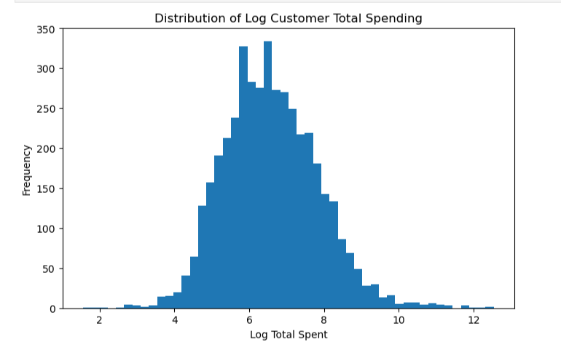
A monthly sales summary also showed a clear rise in sales across the later months in the data set. The strongest totals appeared in months 10, 11, and 12, which suggests that seasonality may be meaningful in later modeling. This finding supports the inclusion of time-derived features such as month, quarter, or seasonal indicators in later work.

Figure 2
Monthly Total Sales
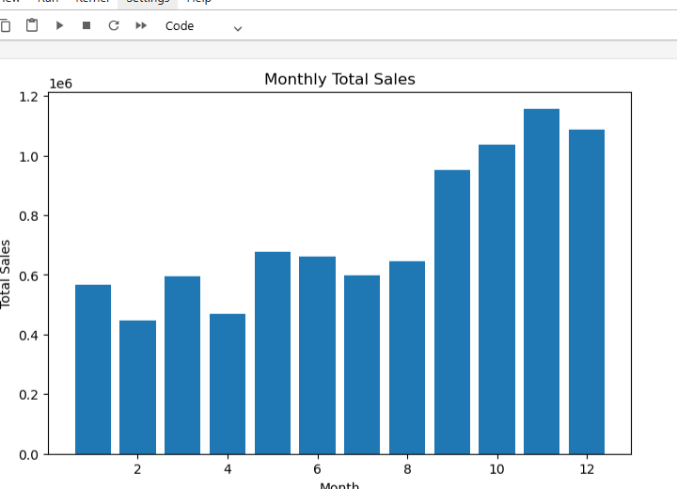
Country-level exploration revealed that the United Kingdom dominated total sales by a very large margin. That result is not surprising because the retailer is based in the United Kingdom, but it still matters analytically. Country is likely to carry useful signal, yet the heavy concentration in one country also means later models should be interpreted carefully because the data is not evenly distributed across geographic groups.

Figure 3
Top 10 Countries by Total Sales
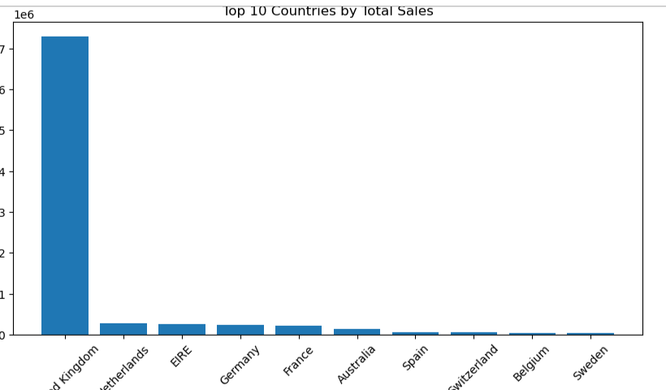
Taken together, the EDA results suggest that later modeling should use careful scaling, transformation, and grouping strategies. Outliers should not be ignored, time-related features appear informative, and the data structure is suitable for moving from transaction-level exploration to customer-level modeling in future deliverables.
Insights and Implications for Future Modeling
This first project deliverable produced several useful insights that will guide the next stage of the project. First, data quality issues were substantial enough to require deliberate cleaning before any serious modeling could begin. Second, the strong skew in sales values indicated that raw spending is not an ideal direct target without transformation. Third, the monthly sales pattern suggested that time features may improve future model performance. Fourth, the strong dominance of United Kingdom transactions showed that country effects exist, but they should be interpreted with caution because of class imbalance at the country level.
Another important lesson from this project deliverable is that customer-level aggregation is likely to be more useful than relying only on individual invoice lines. The cleaned transaction data now supports creation of customer behavior features such as total spending, number of transactions, average unit price, and active months. Those features are better suited for regression, classification, and clustering than the original raw line items alone.
Conclusion
Overall, Project Deliverable 1 successfully completed the required tasks of data selection, loading, cleaning, and exploration. The Online Retail data set met the project requirements and provided a strong foundation for future analysis. The cleaning process removed missing, duplicated, and invalid records, while exploratory analysis revealed important patterns related to skewness, outliers, seasonality, and geographic concentration. These findings established a reliable starting point for the next phases of the project and clarified several modeling choices that should improve the quality of later results.

References
UCI Machine Learning Repository. (n.d.). Online retail data set. https://archive.ics.uci.edu/

